I, Joshua Leclair, student number 000753701, certify that this material is my original work. No other person's work has been used without due acknowledgement and I have not made my work available to anyone else.

Test Plan

1. Try and access the teams/index page without logging in.
2. Try and access the teams/create page without logging in.
3. Log in as a player.
4. Try and access the teams/index page as a player.
5. Try and access the teams/create page as a player.
6. Log out of player account
7. Log in as a manager
8. Try and access the teams/index page as a manager.
9. Try and access the teams/create page as a manager.
10. Create a new team entry.
11. Update an existing team entry
12. Delete a team entry
13. Log out of manager account.

Reflection

1. Joshua Leclair, 000753701, Lab 1
2. All processes outlined in the test plan appear to be working as intended.
3. I’ve learned how to use the package manager console, how to restrict access to individual pages by user role, and how to seed the database with users and roles.
4. I need to work on remembering how to add database migrations, scaffolding controlers, and setting up model classes.

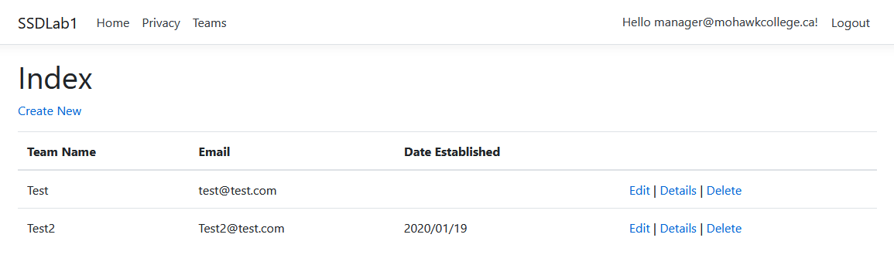

Figure 1 Manager tries to view the teams page

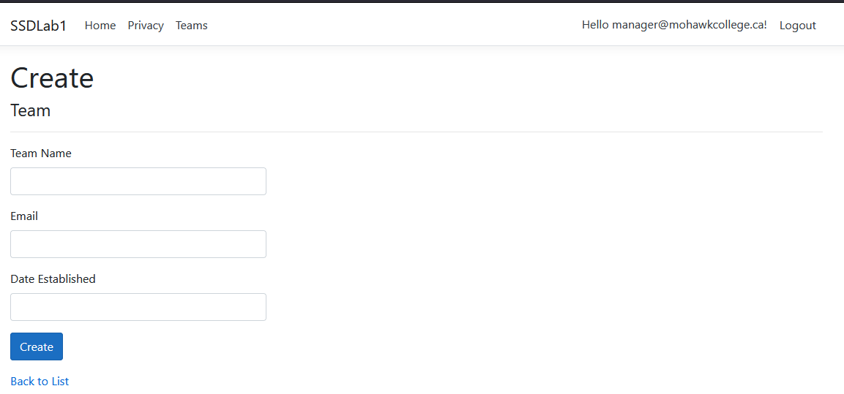

Figure 2 Manager tries to create a new team

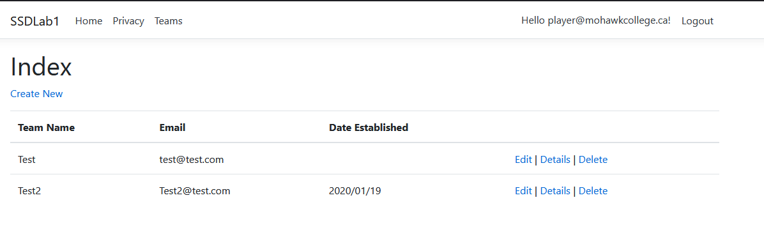

Figure 3 Player tries to view the teams page

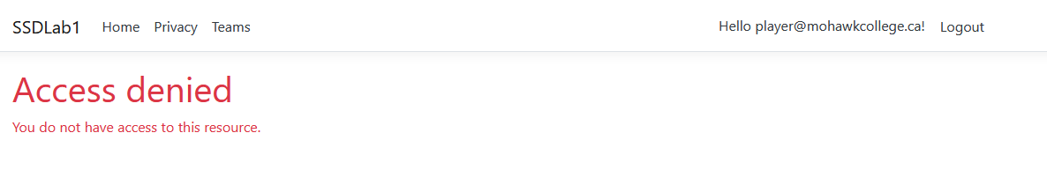

Figure 4 Player tries to create a new team

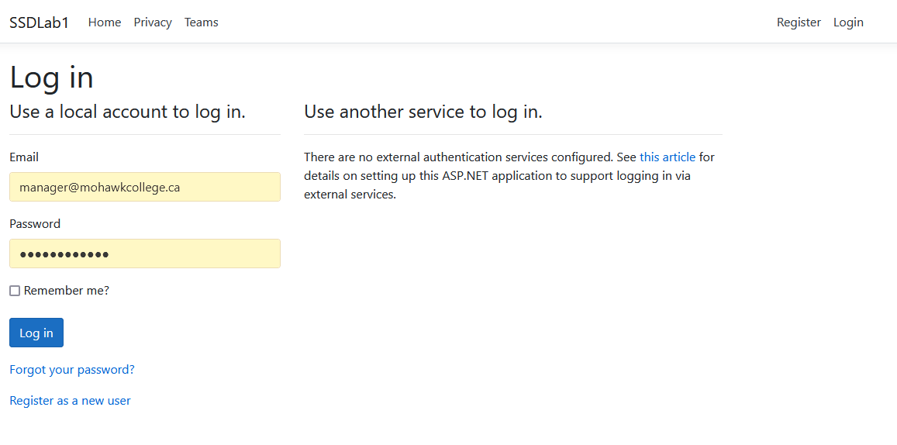

Figure 5 Unauthorized user tries to create a new team or view the teams page